Görkem Enes Bektaş Berke Can Kaya
bektasgorkemenes@gmail.com bluten07@gmail.com
Politechnika Czestochowska Politechnika Czestochowska

Signal Analysis and Data Processing
Laboratory Class - Experiment 7

Spectral analysis using DFT (FFT). Spectral leakage and window functions.

Introduction

The exercise focuses on spectral analysis using Discrete Fourier Transform (DFT) and its implementation via the Fast Fourier Transform (FFT) algorithm. A key challenge addressed is spectral leakage, a phenomenon that occurs due to signal discontinuities within the observation window. To mitigate spectral leakage, the application of smoothing functions, also known as window functions, is explored.
This analysis is crucial in understanding the relationship between the temporal and spectral domains, evaluating how signal properties like frequency range and resolution can be controlled, and implementing techniques to ensure accurate spectral representation of different signal types.

Compulsory Tasks:
- analyse how the spectrum bandwidth (frequency range) and resolution may be controlled,
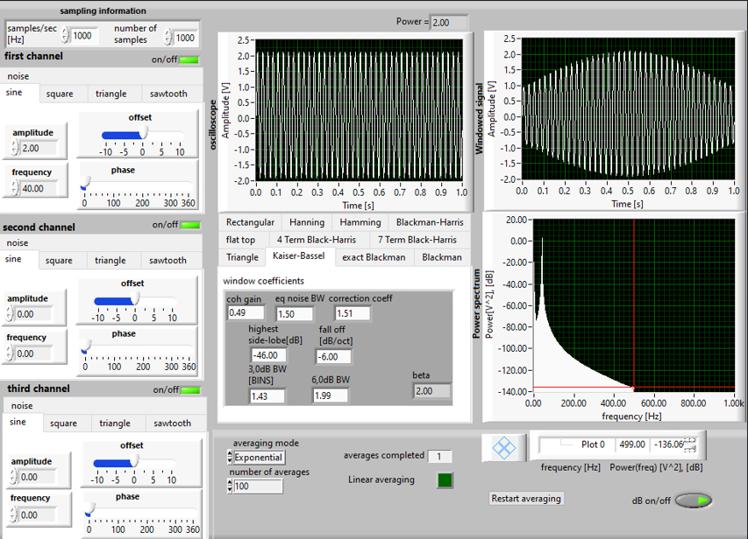
Figure 1.1 Current settings of the LabView
These are the current settings we are using at the moment, in this task, we will try to analyse how we can change our frequency range and resolution;
We can change our frequency range by changing our samples/sec, and we can change our resolution by changing our number of samples.
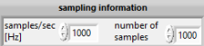
For example, now our number of samples is 1000, and here is our Power Spectrum

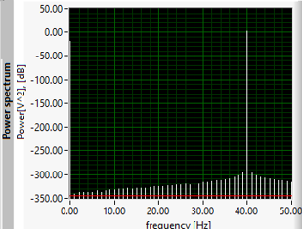
Figure 1.2 Power Spectrum with Number of Samples = 1000

We can change the frequency value by 1 only, for example 10 11 12. So our Resolution equals to 1 at the moment. For example, we will increase our Number of Samples up to 2000 from 1000.

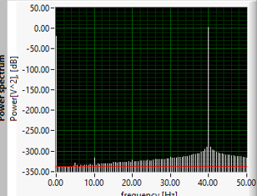
Figure 1.3 Power Spectrum with Number of Samples = 2000

As you can see, we have more lines at the moment, which shows us that we can change our frequency by 0.5 for example. So we can change the frequency like 40 - 40.5 - 41 - 41.5 - 42 for example. So our resolution is equal to 0.5 now.

And now we will try to change our frequency range by changing samples/sec value. Number of Samples value will be constant at 1000.

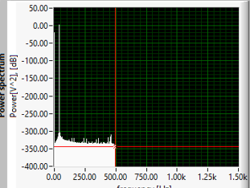
Figure 1.4 Power Spectrum with 1000 Hz Samples/sec

As you can see in our frequency range, 500 Hz is the maximum value. So we should change our Samples/sec value. For example, lets increase it to 2000 from 1000.

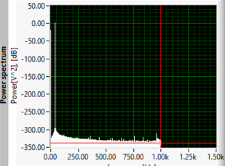
Figure 1.5 Power Spectrum with 2000 Hz Samples/sec

So now on our frequency range, 1000 Hz is the maximum value. We multiplied our Samples/sec value by 2 so also our Frequency range got multiplied by 2.

b) determine spectra for the following signals:
- monoharmonic,
- polyharmonic (e.g. square wave),
- noise,
- compound (e.g. sine wave + noise)

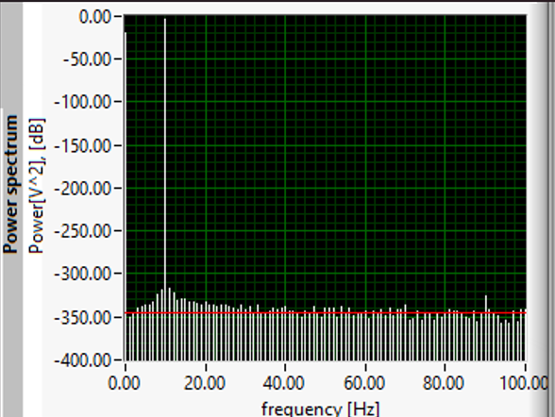
Figure 2.1 Monoharmonic Signal Power Spectrum between 0 and 100 Frequency Range for more clear image.

This is our Monoharmonic signal and here are the settings;
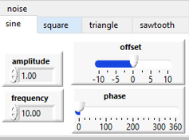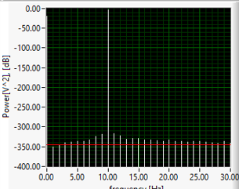

As you can see in our Power Spectrum, our peak value is 10 due to our frequency,
So we can say in Monoharmonic signal, frequency of our sine wave is equal to Peak Value in our Power Spectrum.

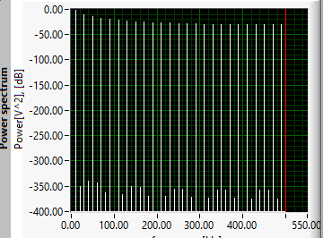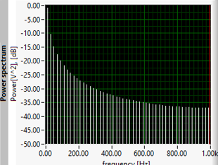
Figure 2.2 and 2.3 Polyharmonic Signal (Square wave only) Power Spectrums at 1000 and 2000 sample.

In this power spectrum, we can see our polyharmonic signal so we have too many peak values. On the left image, we have 1000 number of samples so our range is up to 500 Hz. On the right image, our number of samples value is equal to 2000 so range is up to 1000 Hz.

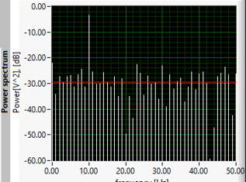
Figure 2.4 Compound Signal (Sine wave + noise) Power Spectrum

In this power spectrum, our frequency is again equal to 10, so our peak value is 10 as we can see.

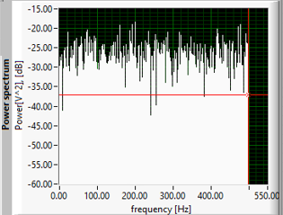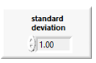
Figure 2.5 Noise signal (Noise only) Power Spectrum

And here we have pure noise so we get this Power Spectrum outcome. Range is up to 500 Hz again.

c) analyse the influence of an incomplete number of sine wave periods on its spectrum >> spectral leakage

In this task, we have our constant amplitude value which is 5, we will change our frequency and we will try to observe the value of Power(freq).

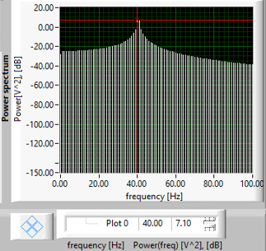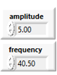
Figure 3.1 Power Spectrum of Rectangular window with 40.5 freq. and 5 amplitude

As you can see here, our frequency value is 40.5 and we have 2 peaks in 40 and 41, our Power(freq) value is 7.1 in this situation, normally it should be 12.5, so our spectral leakage is 12.5 - 7.1 = 5.4 as we calculated.

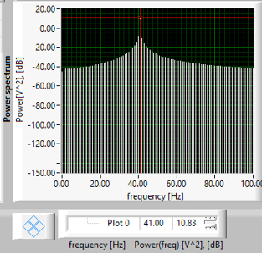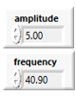
Figure 3.2 Power Spectrum of Rectangular window with 40.9 freq. and 5 amplitude

Also in this image, we can see that we are checking the peak value at 41, and our frequency is 40.9, we can see that now our value of Power(freq) is nearer to our actual Power(freq) value which is 12.5. Because here the difference between frequency and Power(freq) is closer, we have only 41 - 40.9 = 0.1 difference which provides us a Power(freq) value which is more correct than Figure 3.1, because we had more difference between Power(freq) and our frequency.

d) apply various smoothing functions (windows) for the reduction of leakage - perform comparative study and choose the best window taking into account:
height and bandwidth of the main lobe,
side-lobe fall-off.

In this task, we will use 3 different windows and see how our spectral leakage changes, and the window which has the nearest value to our actual Power(freq) which is 12.5 Hz, has the least spectral leakage, and least spectral leakage means best window.

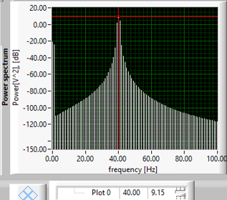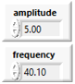
Figure 3.3 Hanning Window with constant amplitude and frequency.

As we can see, our Power(freq) value is 9.15 in the Hanning window, And if we calculate the spectral leakage, it will be 12.5 - 9.15 = 3.35.
So our spectral leakage is equal to 3.35, let's check the other windows and compare it in the last step.

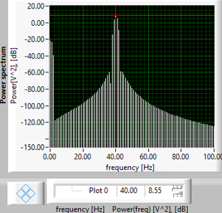
Figure 3.4 Blackman Window with constant amplitude and frequency.

As we can see in this image, we are using Blackman Window and the same values for amplitude and frequency. Value of our Power(freq) in this window is 8.55, so if we calculate the spectral leakage it will be 12.5 - 8.55 = 3.95.

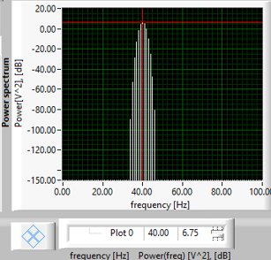
Figure 3.5 7 Term Black-Harris Window with constant amplitude and frequency.

In this image, we have 7 Term Black-Harris window, as we can see the value of our Power(freq) is 6.75, so if we calculate our spectral leakage, it will be 12.5 - 6.75 = 5.75.

At last if we can decide for our best window. It will be the Hanning window due to the least spectral leakage which is 3.35, so the Hanning window is the best among 7 Term Black-Harris, Hanning and Blackman windows.

Conclusion

This exercise provided a comprehensive exploration of spectral analysis using the Discrete Fourier Transform (DFT) and the Fast Fourier Transform (FFT). Central to this study was the understanding of spectral leakage, its origins, and methods to mitigate its effects using window functions. By evaluating different types of signals—including monoharmonic, polyharmonic, noise, and compound signals—under varying conditions, we gained valuable insights into the practical aspects of frequency domain analysis.
Key conclusions include:
- Spectral Leakage and Window Functions: Spectral leakage arises from signal discontinuities at the edges of the observation window, distorting the frequency representation. The use of smoothing functions, such as Hanning, Hamming, and Blackman windows, effectively reduces leakage. The optimal window depends on the application, with trade-offs between the main lobe width and side lobe attenuation.

- Spectral Resolution and Bandwidth: The spectral resolution is inversely proportional to the observation window duration. By controlling the number of samples and sampling frequency, we can balance resolution with bandwidth to suit specific signal characteristics.

- Window Characteristics: The comparative study of different window functions demonstrated their effects on the main and side lobes, highlighting their role in achieving accurate spectral analysis with minimal leakage.

